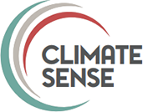

Competencies of climate service and adaptation professionals

Kate Lonsdale, Doogie Black & Briony Turner

Climate Sense
21st December 2023
Climate Sense Ltd
Telephone: +44 (0)1749 674956
Email: kate.lonsdale@climatesense.global
Website: www.climatesense.global
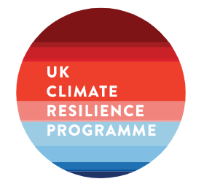
Climate Sense gratefully acknowledges the ’UK Climate Resilience Champion grant (NE/S017321/1) which funded this work.

Contents
What was the motivation for this work? 3
What approach did we take? 4
The need for professionalisation of climate services and adaptation 5
Why is professionalisation important? 5
Support for increased professionalisation: 6
Aspects to address to achieve increased professionalisation: 6
Navigating barriers to professionalisation 7
What is a climate service professional? 7
Characteristics of a ‘good professional’ 7
What makes someone more employable as an adaptation professional? 8
What are the competencies needed by adaptation and climate service professionals? 8
Categorising competencies 8
Adaptation decision framing 9
What competencies were mentioned? 10
Competent person assessment of the ISO Standard 10
Competencies identified in the ECCA interviews 12
Personal qualities 13
Interdisciplinary knowledge 14
People skills 14
Leadership and coordination 15
Communication 15
Working with complexity 16
Mapping ECCA responses to the Adaptation Learning Network, Climate Adaptation Competency Framework 16
Interviews with adaptation professionals 17
Connectivity and Collaboration 18
Adaptability and innovation 18
Knowledge and expertise 18
How do you support the development of adaptation professionals? 18
What kind of support is needed? 18
When is support particularly useful? 19
What other factors would support professionalisation? 19
How do you develop a new professional system for adaptation? 20
What are the are the best routes to the professionalisation of a new field? 20
What are the key components of the professional development system? 21
Building pathways to professionalisation 22

The Climate Services and Adaptation Competencies project

What was the motivation for this work?
When delivering climate services or taking adaptation action, complex and varied data sources are brought together, analysed and processed into advice, products and services. While some elements might be prescribed by regulators this process mostly relies on professional judgement. Given the increasing significance and urgency of adaptation, still a relatively new field for many, there is increasing interest in understanding the skills and experience needed and ways to ensure that we have the workforce with the right experience to deliver it.
Characterising and quantifying climate risk is just one component of adapting to climate change. We also need to manage that risk. Historically, there has been greater emphasis on assessing risk rather than actively managing it. It is increasingly evident that merely assessing risks does not translate into meaningful adaptation action. Increasingly, organisations are taking tangible steps to reduce identified risks. This demands a transition from an emphasis on risk assessment to developing strategies for risk management, and thus, a different set of skills, such as strategy development, effective communication, and negotiation between stakeholders.
Fields like engineering and surveying, typically recognise proficiency, experience and professional competence through accreditation by a professional body. No such standardised mechanisms for professionalisation exist for climate services or adaptation, raising questions about how professional standards are established and maintained.
There have been global efforts to establish standards for data and projects aimed at addressing climate change although these are not yet in widespread use. One issue is lack of quality control in how standards and guidance are applied, and the skills and expertise needed to play a quality assurance role. This makes it hard to define, uphold, and improve the quality of the provision of adaptation and climate services. In addition, what it means to act in a professionally responsible and ethical manner, particularly in terms of public benefit and duty of care, is currently reliant on narrow and often individual interpretations.
Adaptation decisions are made by two distinct groups of people: those whose principal role is dedicated to adaptation and those for whom adaptation is part of a broader professional role. The former group is relatively small, with most people making adaptation decisions in the latter category. Mechanisms for professionalisation need to be applicable to both types of roles.
This project builds on the work of the SPF UK Climate Resilience Programme, led by Climate Sense and JBA, in establishing a Climate Services standard. It focuses on identifying the knowledge, skills, and behaviours necessary to anticipate and respond to the impacts of climate change. Specifically, to explore the competencies needed to develop useful climate services and execute robust and effective adaptation actions with confidence, at the required scale, and at the right time.
This paper aligns with the increasing demand for standards and guidance requiring that specific actions be carried out by ‘competent experts’ (ISO Standard 14090). The paper addresses two central questions:
- What attributes define a "competent expert" capable of implementing a diverse range of actions within a flexible adaptation program?
- How can these competencies be formalised for professionalisation, providing career guidance and supporting the selection of appropriate expertise?
By answering these questions, the paper provides a clearer understanding of the competencies needed for successful climate change adaptation and insights to support professional development and the selection of experts.

What approach did we take?
This brief study began with a desk review of existing work on adaptation competencies, attributes, and professionalisation of individuals engaged in climate change adaptation. This included reviewing the clauses referring to a ‘competent person’ in the ISO Standard on Adaptation to Climate Change- Principles, requirements and guidelines (ISO 14090-2019) and other competency frameworks for adaptation professionals, notably that developed by Resilience by Design, Royal Roads University Canada.
The 2023 European Climate Change Adaptation Conference (ECCA), a biennial event focused on addressing climate change impacts and adaptation strategies in Europe, provided an opportunity to conduct brief interviews with participants from diverse organisations, including academia, government, and NGOs, operating at various scales and career stages. Using the breaks between conference sessions, the researchers gathered opinion on the top three attributes or qualities of a climate change adaptation professional. These discussions provided insight into the essential attributes, qualities, and abilities necessary to deliver climate services and implement climate change adaptation. They also expanded into more in-depth conversations exploring the roles played by adaptation professionals, their personal career trajectories, and the merits and drawbacks associated with professionalisation of the field.
In the final phase, a series of semi-structured interviews were conducted with adaptation professionals and professional bodies. This phase aimed to explore how career development paths for climate services and climate change adaptation could be devised to promote due diligence and quality control within the field.

The need for professionalisation of climate services and adaptation

Why is professionalisation important?
Skilled and experienced people are essential for addressing the complex strategic and operational challenges presented by climate change. Effective decision-making for adaptation needs to be informed by skilled use of climate science and other relevant disciplines to ensure that resources are allocated efficiently, and policy and practice are well-informed.
Professionalisation, through establishing the criteria and standards for development and providing formal processes and peer practice networks, supports people to strengthen their capacity to tackle the complexities of the field, collaborate effectively, drive innovation, optimise resources and ultimately make better decisions. This, in turn, contributes to more robust and sustainable climate adaptation strategies. Useful work on adaptation undoubtedly happens without professionalisation. This short enquiry asks whether a better understanding of adaptation competencies and more structured routes for professionalisation, good practice could be more widespread and with stronger guarantees of quality. This would raise standards and foster greater trust in the work of the sector.
For individuals, accreditation provides recognition and career advancement and some organisations, such as the Met Office, require accreditation for specific roles. Accreditation both validates an individual’s skills and serves as an incentive for professional advancement, often with associated financial benefits.
For organisations there may be commercial and reputational advantage to have an accredited workforce, with direct influence on market competitiveness. Accreditation provides evidence of a team’s quality and expertise, potentially attracting more clients and opportunities.
Beyond these individual and organisational benefits, the development of staff competency also improves the reputation of the entire sector and acts as a mechanism for filtering out unqualified or unscrupulous individuals and organisations. By ensuring that only qualified and ethical professionals are recognised, accreditation enhances the credibility and integrity of the sector as a whole. This is an important benefit in the relatively new sector of climate services which has been described as the ‘wild west’.
The climate services and adaptation workforce is growing yet adaptation practice is relatively new and unregulated. Interviewees raised concerns about how to assess the quality of adaptation practice. There were divided opinions about how formal professionalisation might contribute, with opinions diverging on both the need for it and its benefits. Professionalisation would have to make sense in a highly diverse sector which integrates many other disciplines. Interviewees were unsure how the diverse range of skills needed could be incorporated into a standardised accreditation process that would add value in such a complex and interdisciplinary landscape. Also, as adaptation is usually carried out through other disciplines and areas of expertise there are relatively few roles that focus exclusively on adaptation, so a focus just on adaptation focus might be too narrow.
Rather than increased professionalisation some interviewees expressed a preference for opportunities for learning and professional growth to increase confidence among adaptation practitioners as creating a culture of mutual support between practitioners could be a more effective approach to skill development. To balance this, others saw the professionalisation process as providing this sort of support and learning culture. Key messages from the interviews are summarised below:

Support for increased professionalisation:
- Interviewees recognised the emerging need for formal accreditation by professional bodies and that providing this could stimulate organisations to allocate more focus (and resource) to adaptation;
- Professionals valued having a platform to prove their expertise and skills. Accreditation or formal recognition of expertise is a valuable way to enhance credibility in the field;
- By clarifying the skills needed for adaptation roles, professionalisation could help professionals understand where their skills are needed and recruiters to understand what skills to look for in adaptation roles. The additional clarity about the diversity of competencies needed might also encourage organisations to develop specialised adaptation roles and training providers the courses needed to ensure a more robust adaptation workforce;
- By formalising and standardising the learning process, professionalisation creates a structured framework through which individuals can share their experiences and insights. By fostering a collaborative environment, practitioners can learn from each other, contributing to a more knowledgeable and skilled workforce;
- Professional bodies also provide a platform for individuals to establish and nurture professional relationships, through opportunities to connect with other practitioners. The networking aspect of professionalisation is viewed as a vital component in the continuous development of professionals, allowing them to stay updated on industry trends and best practice;
- By standardising adaptation and climate services competence through professionalisation, you create a common baseline, ensuring that practitioners from various backgrounds possess a consistent set of skills. In this way, professionalisation is a means to enhance inclusivity within the field, acknowledging and valuing the diverse expertise that individuals bring to the profession.

Concerns about achieving increased professionalisation:
- Too few roles focus purely on adaptation to justify the cost and governance of a professional standard solely for adaptation. Adding an adaptation stream to existing professional development requirements for those who need to include adaptation as one aspect of their practice might be a better approach;
- The link between increased professionalisation and greater job opportunities needs to be tested to ensure that time, effort, and resources invested in obtaining professional qualifications can be balanced against career advancement;
- The time and financial commitment required for professionalisation is deterrent for some and providing alternative ways for gaining hands-on experience or flexible learning opportunities, could help people develop relevant skills that align with the current, fast-moving professional landscape;
- The certification processes should not be so rigid that it creates barriers that limit access to the sector for specific groups. Effort is needed to enhance diversity and strengthen inclusion of the professional landscape;
- Some interviewees saw professional bodies as outdated and slow to adapt to technological advancements and changing job markets. To remain relevant, professionalisation approaches would need a range of accessible approaches to learning, such as online courses, participatory workshops, and project-based experiences.

Navigating the barriers to professionalisation
To navigate the challenges identified with increased professionalisation, clear links between professionalisation and career development are needed to demonstrate the positive impact of professionalisation on career advancement. Flexible approaches to learning, different course durations and costs, could reduce barriers for people seeking professional qualifications and catering for the dynamic nature of the professional landscape. Professional requirements need to be proportionate to the nature of the adaptation role. If adaptation is a small part of a much larger role, the requirements would be different in scope and scale to those for whom adaptation is their primary role.
To ensure that increased professionalisation results in a more adaptable and skilled workforce skill development programs need to address the diverse needs of different professions and the interdisciplinary nature of climate change adaptation. As well as accrediting technical skills, they must also assess organisational and negotiation skills, to ensure that professionals have the necessary skills for delivering climate services effectively.
To stay relevant, certification processes and professional bodies need to be accessible and supportive of diverse backgrounds and responsive to evolving demands and technological advancements. Fostering a supportive learning culture through professional forums and collaborative platforms will provide the mutual support practitioners need to work in a new and dynamic field and strengthen the ongoing confidence of the sector.

What is a climate service professional?

Characteristics of a ‘good professional’
A 'good professional' is someone who adheres to industry standards, follows established protocols, and complies with the qualifications and competencies required for their respective roles. Thus, it also means actively updating your approaches to meet emerging best practice and ethical standards, to ensure ongoing quality and integrity in rapidly evolving professional landscape.
A 'good professional’ commits to continuous learning to stay informed about their sector and working practices to ensure approaches remain effective and relevant. By undergoing external evaluation, professionals demonstrate a commitment to accountability which provides reassurance to clients, colleagues, and the broader community that their skills and expertise align with the recognised benchmarks set for the sector.

What makes someone more employable as an adaptation professional?
Given the diverse nature of climate change adaptation and climate services, part of being more employable depends on identifying career goals and areas of interest and exploring how these align to the roles available. This is the foundation for targeted skill development and gaining relevant expertise. Strategies for enhancing employability depend on career stage. People early in their career benefit from formal training to build knowledge on foundational aspects of climate service provision and adaptation. Later on in their careers, people benefit from opportunities for experiential learning that allow them to apply their knowledge and build on existing strengths, first as a team member, contributing to the work, and later initiating, designing and leading the work.
Continuously learning and developing as a professional is essential for adaptation as knowledge and practice is constantly evolving. While possessing a specific adaptation qualification is valuable, a broader perspective can further enhance employability. Professionals often complement their climate change lens with qualifications in related fields. This not only expands the depth of work possible, but also provides a holistic understanding of how climate change adaptation intersects with other domains, fostering a broader awareness of the implications of climate change and minimising maladaptation by encouraging a comprehensive, interconnected approach.
The ability to span different fields and integrate perspectives, despite not being an expert in any particular field, is a highly valued asset for climate service development and climate adaptation. An interdisciplinary approach not only broadens problem-solving capabilities but also enhances collaboration and adaptability. Such a versatile skill set makes professionals more attractive to employers. Looking ahead, an accreditation in climate change adaptation is a future-proofing strategy that can boost employability through demonstrating expertise and a commitment to tackling the evolving challenges of climate change.

What are the competencies needed by adaptation and climate service professionals?

Categorising competencies
In doing this work we reflected on the commonly used, but misleading, dichotomy of ‘hard’ and ‘soft’ skills. Hard skills tend to be used to describe technical skills such as: characterising hazard data and climate modelling; describing climate information; undertaking risk assessments; and providing engineering solutions. It could also extend to economic and financial assessments. Soft skills tend to be used to encompass facilitation, coordination, working with others, reframing / communications, change management, other organisational capabilities (leadership, strategy, operations, procurement, training, HR) and designing processes to enhance learning from delivery.
The dichotomy is unhelpful as the ‘soft’ label implies that these aspects are less important and possibly less difficult to acquire. It is often assumed that people can pick up ‘soft’ skills up without additional training. Dividing skills into these two categories obscures the fact that most skills exist on a spectrum with blurry boundaries. Critical thinking and creativity are also essential for ‘hard’ technical- oriented decision making. Communication, generally considered as ‘soft’ skill, is fundamental for technical and scientific fields.
Skills for climate services professionals will evolve over time as individuals mature, the sector as a whole develops, and with technological advancements, societal shifts, and changes in the nature of work. To be successful professionals will need a combination of technical and interpersonal skills and the ability to integrate and balance these skills to address specific climate adaptation challenges and drive innovation.
The hard/soft boundary is unhelpful for the emerging field of climate services where professionals will be expected to possess a combination of technical proficiency and interpersonal skills to be effective. It thus makes sense to adopt a more holistic approach to skill development that recognizes the interconnectedness and fluidity of skills needed.

Adaptation decision framing
Much of the climate adaptation literature frames adaptation as an intractable, complex or ‘wicked’ issue. This framing emphasises the need to shift beyond technical expertise to a much wider range of skills. These include thinking systemically, collaboration, visionary yet flexible and adaptive leadership, critical thinking, ethical decision–making, empathy and persistence in the absence of easy solutions.
Climate change will affect organisations in different ways, and within particular organisations in different ways depending on the type of decision being made at a given time. Decisions that are made frequently probably do not need to consider the impact of a changing climate as they only have short-term consequences and are easy and cheap to reverse. Organisations making long-term decisions about climate vulnerable assets, long supply and delivery chains, or where responses require working with others, may require new decision approaches to avoid locking into unsustainable paths that would be costly to reverse. Adaptation professionals thus need to identify proportionate responses depending on the context and operate accordingly.
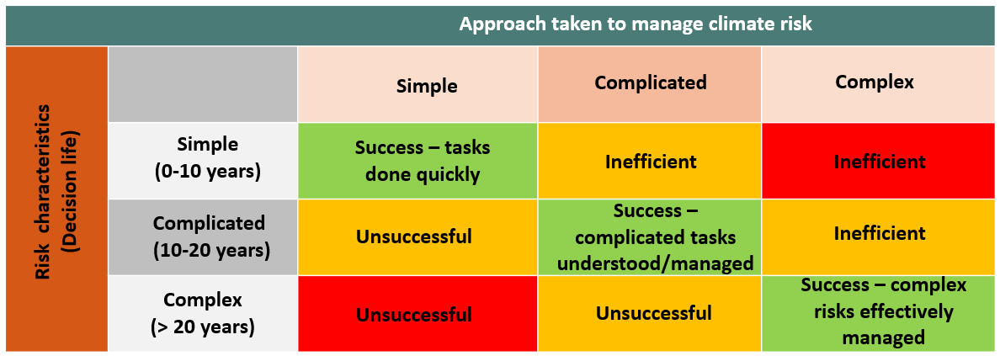
Figure 1: Adaptation professionals will need to be able to identify and implement a proportionate response to climate risks
There is no agreed ‘best practice’ for adaptation decision making (or complex issues, in general) only emerging or promising practice. Practitioners need to be able to makes sense of and navigate situations characterised by constant incremental, and sometimes transformative, change. This involves not only understanding and interpreting the climate-related challenges but also possessing the ability to collaborate effectively with diverse people and, if needed, help to make the difficult decisions involved in transformative societal change.

What competencies were mentioned?
The competencies needed go beyond technical ability. The academic literature on adaptation underscores the significance of processes such as sense-making, negotiation, and social learning and these findings were affirmed in the interviews. Terms like adaptation as 'a process of social learning' and the need for 'negotiated resilience' highlight the importance of collective intelligence, communication, negotiation, problem-solving, conflict resolution, and collaborative decision-making. These processes contribute to co-creating adaptive strategies, that foster innovation, and establish feedback loops for continual improvement.
Early career researchers working on climate adaptation were asked at meeting of the Commonwealth Climate Resilience Network what they would like their superpower to be. The response was ‘humility’ as with humility, you recognise that “expert” disciplinary knowledge is only part of what is needed to understand a problem. If you have humility, you can listen deeply to the communities involved in the work and to value their knowledge. Also, having humility enables to admit to things that have gone wrong or been misunderstood and able to learn, change plans accordingly.

Competent person assessment of the ISO Standard
The ISO 14090 climate change adaptation standard describes internationally agreed best practice for creating effective climate change adaptation programmes. It guides organisations to adapt and improve over time as they learn more and discover better approaches. This continuous improvement process requires all of the qualities that this study identified as elements of professionalism in adaptation. ISO 14090 includes 50 mandatory (‘shall’) requirements that organisations must meet to comply with the standard and 24 recommended (‘should’) actions that they ought to consider to be compliant. In this study, we combined these requirements and recommendations to provide an overview of all the suggestions. We then broke these down into about 100 specific items to explore in more detail. To gain insight into the kinds of competencies needed by good adaptation and climate service providers we compiled a list of the characteristics of ‘a competent person’ mentioned the ISO 14090: Adaptation to Climate Change Principles, requirements and guidelines. These were then grouped into one of three categories:
- Technical competencies: include engineering, risk analysis, and financial competencies.
- Non-technical competencies: include organisational development, leadership, facilitation and communication
- Mixed competencies: include those where technical and non-technical need to work together for the desired outcome.
For example, the text states ’an organisation shall assess its capability to undertake Clauses 6 - 10 by:
- determining the leadership and broader governance required for the climate change adaptation process of the organisation;
- identifying the human resources required including those of any project team(s) involved;
- determining roles and responsibilities;
- identifying the need for financial resources;
- identifying the required levels of expertise and knowledge, as well as information and data sources; and
- identifying the moments when the organisation makes strategic decisions
The implied technical or ‘hard’ skills are:
- Climate data knowledge
- Climate impact / risk knowledge
- Financial assessment (including non-traditional approaches to cost / benefit analysis)
The implied mixed skills are:
- Asset / Service knowledge to understand triggers and thresholds
- Understanding the impacts of climate change
- Translation of scientific information into action
- Risk prioritisation
The implied non-technical or ‘soft’ skills needed to turn information into proportionate and effective adaptation responses include:
- Leadership and broader governance – to inspire and motivate others
- Identifying the range of human resources required
- Stimulating the organisational change required
- Facilitation of new approaches to decision making e.g., adaptation pathways
- Convening multiple actors across the relevant decisions
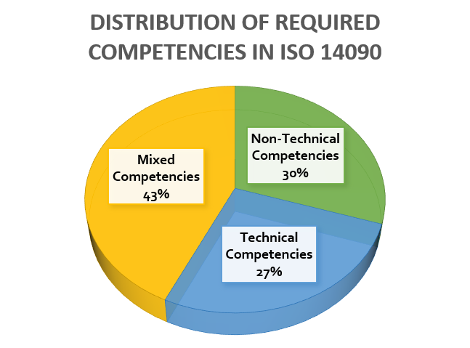
- Managing multiple drivers for change
This ‘competent person’ assessment of the complete ISO 14090 standard text identified, one hundred separate characteristics. Of these, 27% referred to technical (or financial) competencies, 30% referred to non-technical (e.g. organisational development) competencies in isolation, and 43% required a combination of technical and non-technical competencies. Thus, 63% of all requirements require some element of organisational development and expert facilitation competencies.
Figure 2: Distribution of required competencies in ISO14090 Interviews with adaptation professionals.

Competencies identified in the ECCA interviews
During the 2023 European Climate Change Adaptation Conference (ECCA), 47 people participated in brief interviews. They represented a wide range of experience and career stage, including undergraduates, post-graduates, interns, newcomers to professional positions, recently established practitioners, long established practitioners, academics and professionals.
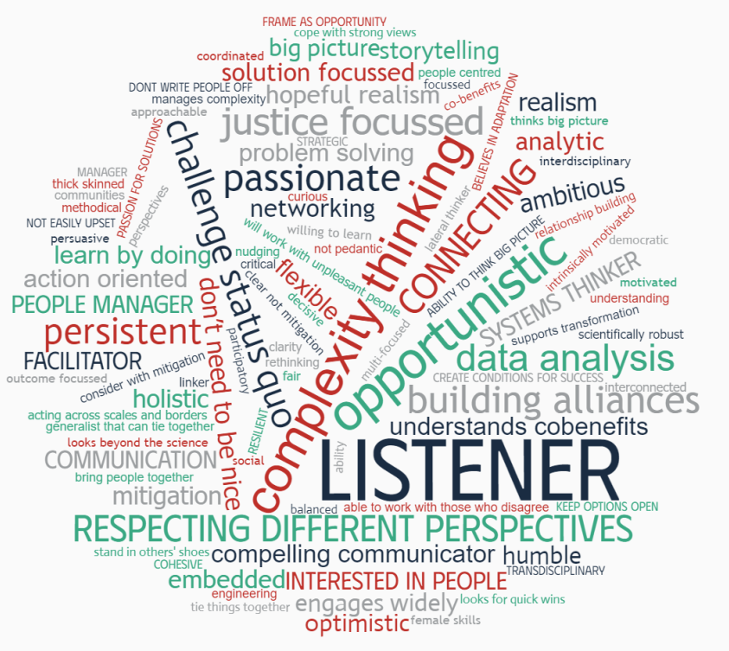
Almost all those who have been practitioners for a decade or more acknowledged a significant transformation in the professional landscape in recent years. Initially their focus had been on advocating for adaptation action. This has now shifted to designing adaptation strategy and action and identifying metrics and mechanisms for measuring progress. This has an influence on the competencies needed by an adaptation professional. Their responses were captured in the word cloud below.

Figure 3: Word cloud generated from 47 ECCA interviews to the question ‘What are the three key attributes or qualities of an adaptation professional?’

The qualities and attributes identified in these ECCA interviews were categorised as below. Please note that these categories are not rigid and some qualities could fit within more than one category:

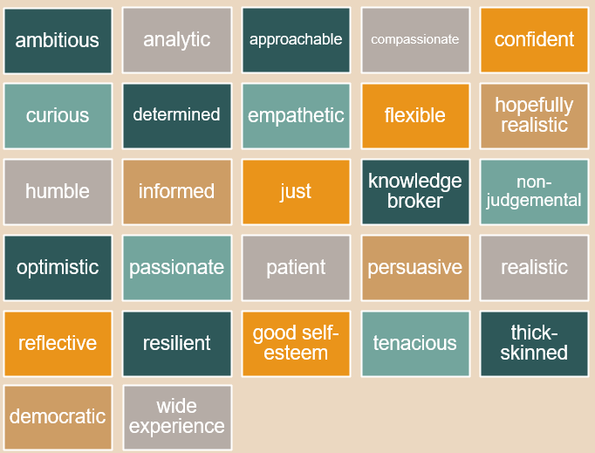
Personal qualities
The qualities of a good adaptation professional described in the interviews denote people with wide-ranging experience, a diverse skill set and a wealth of knowledge. They tend to have good self-esteem, are able to acknowledge their strengths while remaining humble and open to improvement. This ability to learn and develop contributes to their effectiveness across diverse settings.
Figure 4: Personal characteristics of adaptation professionals from ECCA interviews
Ambition and determination are highlighted, suggesting an inner drive supported by being both realistic and optimistic which enables adaptation professionals to achieve goals and professional growth, despite setbacks. Interviewees mentioned ‘analytic’ and ‘curious’ as important qualities, implying a thoughtful and inquisitive approach, useful for understanding complexity and finding innovative solutions.
Ambition and drive are complemented by approachability and compassion, suggesting that effective adaptation professionals are not only competent but also easy to get on with and effective collaborators. Confidence is balanced with humility, suggesting they are open-minded, non-judgmental in their attitude. They are also informed, acting as a knowledge broker who synthesizes information effectively and shares insights with others.
Adaptation professionals also have qualities of justness and fairness in their dealings, emphasising ethical decision-making and justice. This suggests a person who is passionate about their work, deeply committed, while able to address challenges with patience and resilience. This flexibility and reflectiveness enable them to adapt to changing circumstances while continuously learning and growing. They are persuasive communicators, able to convey ideas effectively and influence others positively. This person is tenacious and thick-skinned, able to withstand challenges and setbacks without losing determination.

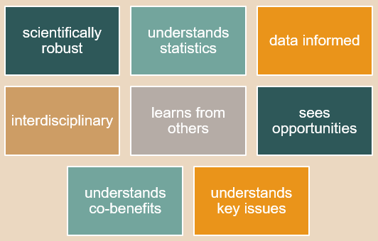
Interdisciplinary knowledge
The qualities emphasised suggests a scientifically grounded, data-informed, and interdisciplinary professional who values collaboration, sees opportunities in challenges, understands co-benefits, and possesses a nuanced understanding of key issues.
To be effective as an adaptation professional means having a robust scientific grounding when addressing challenges and adept at analysing and interpreting data, to support informed decision-making.
Figure 5: Interdisciplinary knowledge skills of adaptation professionals from ECCA interviews
Their interdisciplinary approach reflects a capacity to integrate knowledge from various fields, fostering a holistic understanding of complex issues, enabling them to connect dots and see relationships between seemingly disparate pieces of information.
Understanding co-benefits is a key strength, suggesting an appreciation for the interconnectedness of issues and the potential for positive outcomes across multiple domains. This is underpinned by a willingness to learn from others and valuing input and expertise from diverse sources, recognising that different perspectives enhance problem-solving.

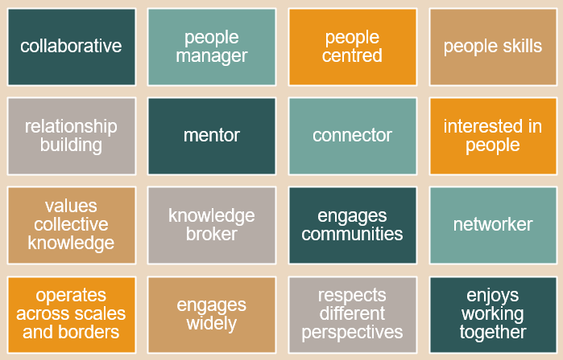
People skills
Someone with the skills mentioned is highly people-focused and collaborative, excelling in building and nurturing relationships across various scales and boundaries. They thrive in team environments and seek opportunities to work collectively. They are good at leading and guiding teams, supporting colleagues to build on their strengths and foster an inclusive work culture.
Figure 6: The people skills of adaptation professionals from the ECCA interviews
They value collective knowledge and diverse perspectives within a community or organisation. They operate as a mentor, and support to others in their professional and personal development. Additionally, they play the role of a connector, actively facilitating meaningful connections between individuals and groups, communities and networks. As an active networker, they can establish and nurture connections widely with different stakeholders, respecting diverse perspectives and building bridges between different points of view.

Leadership and coordination
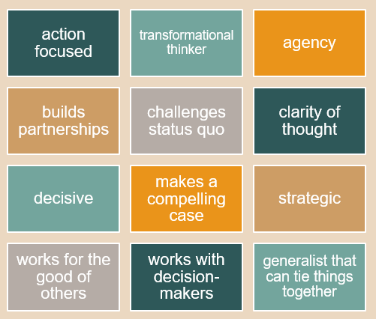
Someone with this set of skills is a dynamic and visionary individual and able to think transformationally. They are action-focused, actively seeking tangible results and progress. As transformational thinkers, they are not confined by conventional boundaries and instead look for meaningful and innovative solutions to challenges.
Possessing a strong sense of agency, adaptation professionals tend to take the initiative and assume responsibility for making changes which often requires building partnerships and alliances to achieve shared goals. They have the ability to challenge the status quo, bring fresh perspectives and foster a drive for innovation and improvement.
Figure 7: Leadership and coordination skills of adaptation professionals from the ECCA interviews
Leadership qualities for adaptation professionals also include clarity of thought and decisiveness in decision-making. They are strategic thinkers, able to see the bigger picture and plan for the future and able to make a compelling case when conveying their vision, inspiring others to act. Working for the good of others is a core value, reflecting a sense of altruism and a commitment to a better society. They are adept at working with decision-makers, influencing strategic directions and aligning efforts with overarching goals and able to tie various elements and concepts, together to provide a holistic understanding of complex situations.

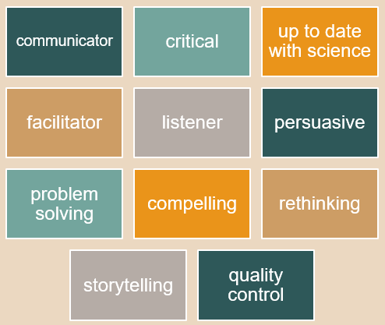
Communication
Someone with this set of skills is a highly effective and versatile professional, adept at conveying ideas and information clearly and succinctly. Their critical thinking skills enable them to analyse information thoughtfully and with discernment.
Effective adaptation professionals are committed to staying informed about the latest developments in their field. As facilitators, they are able to guide and streamline processes, foster a conducive environment for collaboration and effective teamwork. Importantly, their role as a listener signifies an openness to different perspectives and a genuine interest in understanding the perspectives of others.
Figure 8: Communication skills of adaptation professionals from the ECCA interviews
They are able to influence others through compelling arguments. Problem-solving is approached with creativity and strategic thinking, allowing them to navigate challenges with agility. The skill of compelling storytelling enhances their ability to engage and connect with audiences, making complex concepts more accessible. Rethinking is a key aspect of their approach, indicating a capacity for innovation and adaptability and quality control reflects a commitment to maintain high standards in their work.

Working with complexity
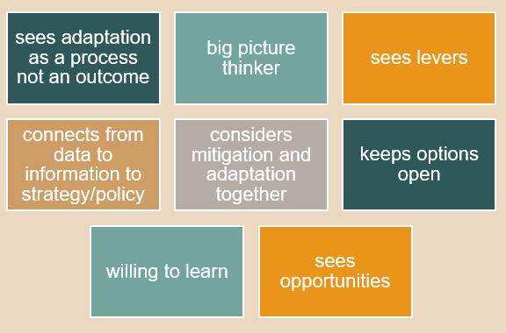
Someone with these skills is a strategic, adaptable, and forward-thinking professional who sees adaptation as a dynamic process and embraces opportunities for positive impact within the broader context of climate change. Being adept as an adaptation professional requires the ability to navigate the complexities and ‘mess’ of adaptation in the context of climate change. They view adaptation as an ongoing process rather than a static outcome, reflecting a dynamic and continuous approach to addressing challenges.
Figure 9: The working with complexity skills of adaptation professionals from the ECCA interviews
Being a big picture thinker, this individual possesses the ability to grasp and conceptualize complex systems and interactions. They can identify key elements within the broader landscape, allowing them to develop comprehensive strategies that consider various factors and potential outcomes.
The skill of seeing levers suggests a capacity to identify influential points within a system that can be leveraged to achieve desired changes. This skill, aligned with the ability to connect from data to information to strategy/policy, suggests being able to shift between holistic approach, ‘whole system’ approach and specific opportunities to create practical change. Such people can not only gather and analyse the relevant data but also translate this information into actionable strategies and policies. The inclination to keep options open suggests adaptability and a willingness to adjust strategies based on evolving circumstances. A strong willingness to learn indicates a proactive mindset, acknowledging the dynamic nature of climate issues and the need for continuous learning.

Mapping ECCA responses to the Adaptation Learning Network, Climate Adaptation Competency Framework
The Climate Adaptation Competency Framework developed by Royal Roads University for the Adaptation Learning Network was motivated by the certainty that climate change, and the actions taken adapt to it, will significantly affect employment and create changes to the workforce with the growth of "green jobs". Despite this, there was limited understanding of the competencies and proficiency levels needed for specific roles or functions. This competency framework outlines the core competencies required for adaptation specialists or professionals integrating climate change and adaptation into existing roles. The framework organises competencies into related groupings and can be used to identify the competencies needed for specific jobs, roles or disciplines.
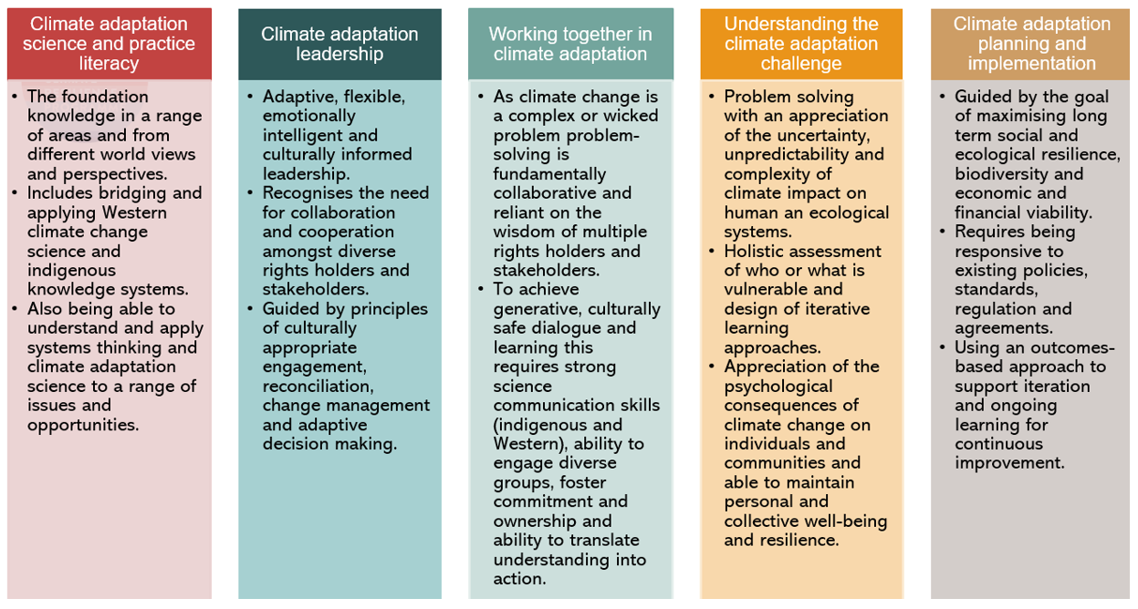
Figure 10: Competency domains of the Climate Adaptation Competency Framework
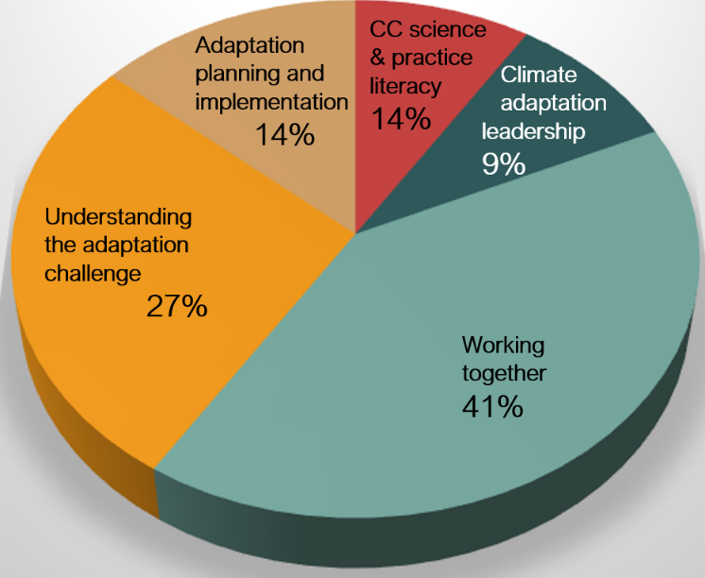
We mapped the skills and qualities named in the ECCA interviews to the competency domains of the Climate Adaptation Competency Framework. Fewer than six percent of the ECCA interview participants highlighted ‘expertise in climate change science and practice’ as their top priority.
This low percentage might be because people assume that technical skills are needed. However, it is evident that respondents valued having a range of skills in addition to technical ones, with reflections that gaining technical insight was not ‘the hard bit’, as the necessary soft, facilitative and analytical skills were considered harder to develop.
Figure 11: Mapping of ECCA adaptation professional skills and qualities to the Climate Adaptation Competency Framework
Responses show clearly that non-technical abilities are highly valued. Most respondents emphasised the importance of being able to work collaboratively across different fields, skills, and perspectives as a fundamental skill

Interviews with adaptation professionals
The in-depth interviews also explored the competencies needed by adaptation professionals and how professionalisation might have helped (or hindered) the development of their career. In addition, interviewees provided their thoughts on accreditation and training of adaptation professionals in the future. The required competencies for adaptation professionals from these interviews aligned with those from the ECCA interviews, providing some additional extra insight and emphasis.

Connectivity and Collaboration
Interviewees underlined the importance of not operating within too narrow an adaptation niche but instead fostering connections across interconnected systems. Addressing climate challenges requires a collective approach rather than working in isolation. Climate risks are pervasive across all policy areas within an organisation, and adaptation efforts need to be integrated across diverse sectors. To achieve this, the ability to bring together partners with broader remits is crucial, while also ensuring efforts are streamlined to avoid duplication. This coordination and convening capacity is undervalued.

Adaptability and innovation
Insights from the interviews underscored the importance of having the ability to navigate complexity, especially in the absence of established solutions, which, in complex situations, is often the case. To be adaptable requires the ability to modify existing methods and innovate creatively, ‘on the hoof’ and often in the absence of clear goals and targets nationally, locally or at an organisational level. The lack of these can make it hard for people to feel they have ‘permission’ to work on climate adaptation given other pressures on time and resources. The integration of adaptation into broader business-as-usual practices was emphasised, particularly as it signified a shift to acknowledging its relevance across all departments and not solely the environment department.

Knowledge and expertise
The interview insights emphasised that although it is important to pay heed to comprehend climate science, engineering solutions, and effective communication there is also an important role for a generalist in the field of climate adaptation. The role requires the ability to convene people to identify, prioritize necessary changes. For this role an in-depth understanding of climate science is less crucial then proficiency in facilitating processes of change. Additionally, the capacity to draw on diverse sources of information and leverage them for achieving meaningful change is deemed essential for professionals working in climate adaptation, underlining the multifaceted nature of the challenges.

How do you support the development of adaptation professionals?

What kind of support is needed?
A well-rounded learning approach is needed for effective professional development. This entails a combination of formal education, on-the-job training, and practical experience. One interviewee suggested that approximately 30% of the learning should be formal, complemented by on-the-job experience and learning from colleagues. The following elements could be included in a comprehensive approach:
Integration into formal education e.g. the incorporation of climate adaptation courses into degree or master's programs to provide an early introduction to potential career paths.
Formal accredited professional training: Formal training, especially if accredited, is highlighted as a valuable component for providing structured and standardised learning opportunities. This emphasises the importance of recognised and accredited programs to ensure that the professional development is aligned with industry standards. Early career training in specific areas such as green finance, facilitating adaptation in organisations, monitoring and evaluation, and cost-benefit analysis is valuable for making career advancements and contributing to climate resilience efforts.
Learning from colleagues: Opportunities to work alongside others, such as through communities of practice, play a vital role in facilitating skill development and knowledge sharing. This collaborative approach enables individuals to learn not only from structured educational programs but also from the practical experiences and insights of their peers tackling similar challenges.
Participating in practice networks: Access to practice networks provides practical insights and resources, gained from experience. This contributes significantly to ongoing professional development and motivation, particularly during periods when progress is slow.
Participation in webinars and conferences: Engaging in webinars and conferences is recognised as a valuable means of building networks and staying informed and connected in the field. This underlines the importance of continuous learning through events that offer opportunities to connect with professionals, share knowledge, and stay abreast of the latest developments in the field.
Mentorship and Guidance: Having mentors provides valuable, tailored guidance and encouragement to help people identify strengths and goals and make better informed decisions on personal and professional development, potential career paths and with developing essential skills.

When is support particularly useful?
There are specific stages and situations in a professional journey where support is particularly beneficial. Interviewees suggested the following moments:
Early Career Development: Support is especially crucial during the early stages of one's career. This includes access to mentorship programmes, early career training, and integration of climate adaptation into formal education. At this early point in their careers people benefit greatly from guidance, skills development, and exposure to potential career trajectories.
Transition Points: Support is highly valuable during transitional phases where individuals are looking to develop new skills or transitioning into leadership roles where formal accredited training and support with understanding good governance of adaptation might be valuable. These transition points often involve acquiring new responsibilities, and targeted support can enhance the effectiveness of these transitions.
Ongoing Professional Growth: Support remains essential throughout one's professional journey, emphasising the importance of continuous learning. This includes opportunities to learn from colleagues, participation in webinars and conferences, and access to practice networks. Professionals encounter evolving challenges and staying informed and connected is critical for ongoing growth and adaptability.
When progress is slow and when facing challenges: Support is particularly beneficial during periods of slow progress or when facing challenges. Access to practice networks and resources can provide motivation and practical knowledge to overcome obstacles. This kind of support ensures that individuals remain resilient and motivated during challenging phases in their careers.
When transitioning to more specialised roles: Support is instrumental during career transitions, and training in specific areas becomes particularly valuable during these transitions, providing individuals with the necessary skills and knowledge for success in these specialised roles.

What other factors would support professionalisation?
Interviewees felt that while there was now less need to explain what climate adaptation is, there is still work to be done to justify and promote adaptation actions. Particularly within the business world, where the framing has shifted from seeing climate change as an environmental concern to being a core business risk. However, the focus remains on assessing risks with insufficient attention to making adaptation decisions. A resource gap persists in delivering adaptation efforts. In some cases the roles do not exist, and in other roles exist but people with the competencies required are not available. Engaging senior management is key to leveraging the support needed and improving access to resources. Interviewees identified some additional factors that would support progress towards a more professional and fit for purpose adaptation workforce.
Accessible climate information: Despite a wealth of climate information a translation gap exists between turning this useful resource into practical action. Early career adaptation professionals reported struggling to source reliable information that strikes the right balance between being too general or too narrowly scientific. This information is not conveniently available in one accessible location.
Centralised job information for adaptation and climate services: Many individuals do not know where to look for adaptation job opportunities. While larger organisations advertise for adaptation professionals, smaller entities often look for individuals with more diverse skills who can mainstream adaptation practices into a variety of roles.
Recruiters with greater awareness of the role requirements: Recruiters often lack in-depth knowledge about the skills and qualifications required for adaptation roles beyond a basic understanding of climate science. This hinders their ability to identify of suitable candidates for adaptation positions.
Support for making a business case for adaptation action: Businesses also experience practical challenges in including adaptation considerations in business case approval processes as their focus only extends 3-5 years. Influencing change and implementing adaptation plans require additional resources and expertise
Research funding for managing climate risks: Existing research funding opportunities tend to emphasise skills in scientific research, data analytics, and evidence creation. While these are important, without the other skills mentioned above, they may not adequately support the practical implementation of climate change adaptation strategies. Accessing funding for adaptation projects can be time-consuming, sometimes exceeding the duration of actual project implementation. This impedes progress in adaptation efforts.

How do you develop a new professional system for adaptation?

What are the best routes to the professionalisation of a new field?
- Demonstrate there is a genuine need: To initiate the professionalisation of a field, it is essential to demonstrate a genuine and consistent need for the work being professionalised and showcasing its potential to benefit humanity in a verifiable manner. This involves establishing a clear connection between potential professionalisation efforts and the positive impact they can have on society.
- Build on existing mechanisms of relevant professional bodies and organisational Continuing Professional Development (CPD) activities.
- Establish a comprehensive framework: This is the foundation of professionalisation. It involves creating a set of standards and competencies against which individuals can be assessed. This framework provides a structured approach to evaluating and ensuring the quality and proficiency of professionals in a new field.
- Review existing standards and accreditation schemes and assess gaps: Before implementing a professionalisation initiative, a thorough review of existing standards, accreditation schemes, and best practices is crucial. This helps to identify elements that can be adapted and reveals gaps that require new standards.
- Consider the forms of accreditation: This requires recognition that not everyone currently operating in the field may have traditional qualifications. Thus it becomes essential to develop experiential routes for assessing competence, for example through extended interviews or alternative assessments. This ensures that a diverse range of qualified individuals can be shown to be contributing usefully to the field.
- Financial Considerations: Developing a well-thought-out financial plan is necessary to cover start-up costs, manage cash flow, and address overheads until the professionalisation process becomes self-funding. Good financial planning ensures the long-term sustainability and success of the professionalisation initiative.

What are the key components of the professional development system?
An effective professional development system should not only elevate individual professionals but also build the overall reputation of the entire profession. A number of essential components were recommended.
- Continuing Professional Development (CPD): In a rapidly changing field, professionals should demonstrate their commitment to staying up to date by participating in continuing professional development (CPD) activities. An online platform can be used to maintain evidence of CPD activities.
- Training Programme: tailored to the specific knowledge and competencies needs of the profession. This ensures that individuals are equipped with the knowledge and skills necessary for success.
- Collaboration with accredited training providers: to deliver good quality training programmes that meet recognised standards.
- Candidate Testing: a testing or assessment process for candidates to ensure that they meet the established standards for the profession and demonstrate the required knowledge and competencies. Competency is assessed through a professional accreditation scheme, which evaluates their ability to meet and apply industry standards.
- Evidence of knowledge and skills: a robust accreditation systems evaluates professionals’ ability to meet and apply industry standards. This evidence, coupled with an awareness of industry standards and strong interpersonal skills, provides the foundation of a professional system.
- Professional Register: an up-to-date register of professionals who have successfully completed the training and testing requirements.
- Code of Conduct: which outlines ethical and professional standards expected within the field. Adherence to this code is essential for maintaining professional integrity. An auditing process needs to be in place to monitor and assess professionals' ongoing conduct, including the ability to strike off professionals who bring the profession into disrepute.
- Online Application System: An online system streamlines the application and assessment process for professional development. This system can facilitate record-keeping and assessment procedures.
- Managing Conflicts of Interest: The system should have mechanisms in place to address conflicts of interest in the assessment of professionalism, ensuring objectivity and fairness.
- GDPR Compliance: Given the importance of data privacy, professionals should have the capability to manage GDPR regulations when handling data related to professional development.

Building pathways to professionalisation
We conclude with next steps for developing this work. Firstly, review the learning outcomes and competencies for diverse professional roles set by relevant organisations. Professionalisation schemes are likely to be dynamic, requiring continuous evolution to incorporate new areas and criteria. This emphasises the need to use annual appraisals and opportunities for continuing professional development (CPD) to continuously enhance knowledge and skills and help to provide additional evidence of ongoing competence. The next stages of the work could involve collaboration with organisations who might play a leading role in professionalisation, for example, professional bodies such as Institute of Environmental Management and Assessment (IEMA), Royal Society, Royal Academy of Engineering, Chartered Institute of Water and Environmental Management (CIWEM), Chartered Institute of Building Services Engineers (CIBSE), and planning bodies.
Formal accreditation relies on competent volunteer assessors to play the crucial role in evaluating candidates. Ensuring the recruitment and ongoing competence of such assessors is integral to maintaining the integrity of the accreditation process. In the multidisciplinary field of adaptation work, professionals' skills vary widely, ranging from data science to structural engineering or human psychology. The complexity of individual roles, whether in asset management, sector-specific planning, or national-level initiatives, poses a challenge to standardising professionalisation.
Drawing a parallel to the medical profession where professionals develop foundational skills before specialising, professional bodies could provide the common knowledge base and skill set for the adaptation profession. This stratified approach mirrors the need for both generalists with basic skills and specialists in specific areas, ensuring a well-rounded and adaptable professional workforce. The support offered by the professional bodies we spoke to included:
- Training and education: introductory and higher-level courses, MOOCs, 1-day training on climate change communication, mentoring scheme, masterclasses for practical applications; support for teachers and climate change education in the classroom.
- Professional certification and accreditation: Chartered Environmentalist; Registered Environmental Practitioner; IEA Quality Mark (a scheme operated by IEMA); Auditing and Continuous Professional Development (CPD) for assessors.
- Knowledge Sharing and Events: Holding registers of professionals; About 60 events per year for knowledge sharing; Climate Change Forum (CCF) with panel discussions and breakout groups; Events and discussions related to IPCC reports and climate science.
- Networking and Community Building: Voluntary but encouraged for practitioners with specific credentials; some events are more focused on networking, especially for the younger generation.
- Communication and Media Support: Training on effective climate change communication; Avoiding pitfalls of greenwashing; Targeted at media organisations, religious bodies, and community organisations.

International Organisation for Standardization (ISO). (2019). ISO 14090:2019 - Adaptation to climate change - Principles, requirements and guidelines.
Cox R, Niederer S, Forssman (2019) Adaptation Competency Framework, Resilience by design, Royal Roads accessed at: https://can-adapt.ca/sites/weadapt.org/files/aln-competencyframework_2021_1.pdf
https://climate-adapt.eea.europa.eu/en/mission/events/6th-european-climate-change-adaptation-conference-2023
Robledo C, Bieri S, Eschen R et al (2023) Promising practices for dealing with complexity in research for development, Gaia- Ecological Perspectives for Science and Society.
e.g. Wals, A. E. J. (2007). Learning for Sustainability: The Role of Education. International Journal of Sustainability in Higher Education, 8(4), 339-351. Pelling, M., & High, C. (2005). Understanding adaptation: What can social capital offer assessments of adaptive capacity? Global Environmental Change, 15(4), 308-319. Brown, K. (2011). Global environmental change I: A social turn for resilience? Progress in Human Geography, 35(3), 309-317.
Harris, L, Chu E and Ziervogel G (2017) Negotiated Resilience, Resilience: International Policies, Practices and Discourses, Vo; 6, 2018, 3 pp196-214.
Copyright © (2019) International Standardisation Organisation (ISO) 14090:2019 - Adaptation to climate change - Principles, requirements and guidelines

